|  |  |  |  |  |  |  |  |
| --- | --- | --- | --- | --- | --- | --- | --- |
| Test No | What is it being tested | Input | Example | Expected Outcome | What was the Outcome | Pass/Fail | What I did to make it work (if needed) |
| 1 | Play Button | N/A | Play | Should click and randomise the icons | It randomised the icons | Pass | N/A |
| 2 | Quit Button | N/A | Quit | Should end the program | It closed the program | Pass | N/A |
| 3 | Table Grid | N/A | N/A | The table should be shown on form | It was shown on the form | Pass | N/A |
| 4 | Labels can click | N/A | Label 2 | The labels should click | Some will click some didn’t | Fail | Just had to add a click event to each of the not working labels |
| 5 | Icons show | N/A |  | Once it is clicked, labels should show | Some didn’t some did | Fail | Just had to add the click event from above and change some of the values |
| 6 | Randomisation | N/A | Position C3,R2 | Once you click the play, it should randomise | A click flash in the table | Pass | N/A |
| 7 | Matching Pairs | Two click events |   | If it the same it should match and then should disappear | Pairs matched but no disappearance | Fail | Couldn’t do anything to do, I tried it wouldn’t work |
| 8 | Pop-up | N/A | “ ” with an ok button | Once all matches have been paired, it show a pop-up. Once pressed Ok it should close | Pop-up did show and it closed the program | Pass | N/A |

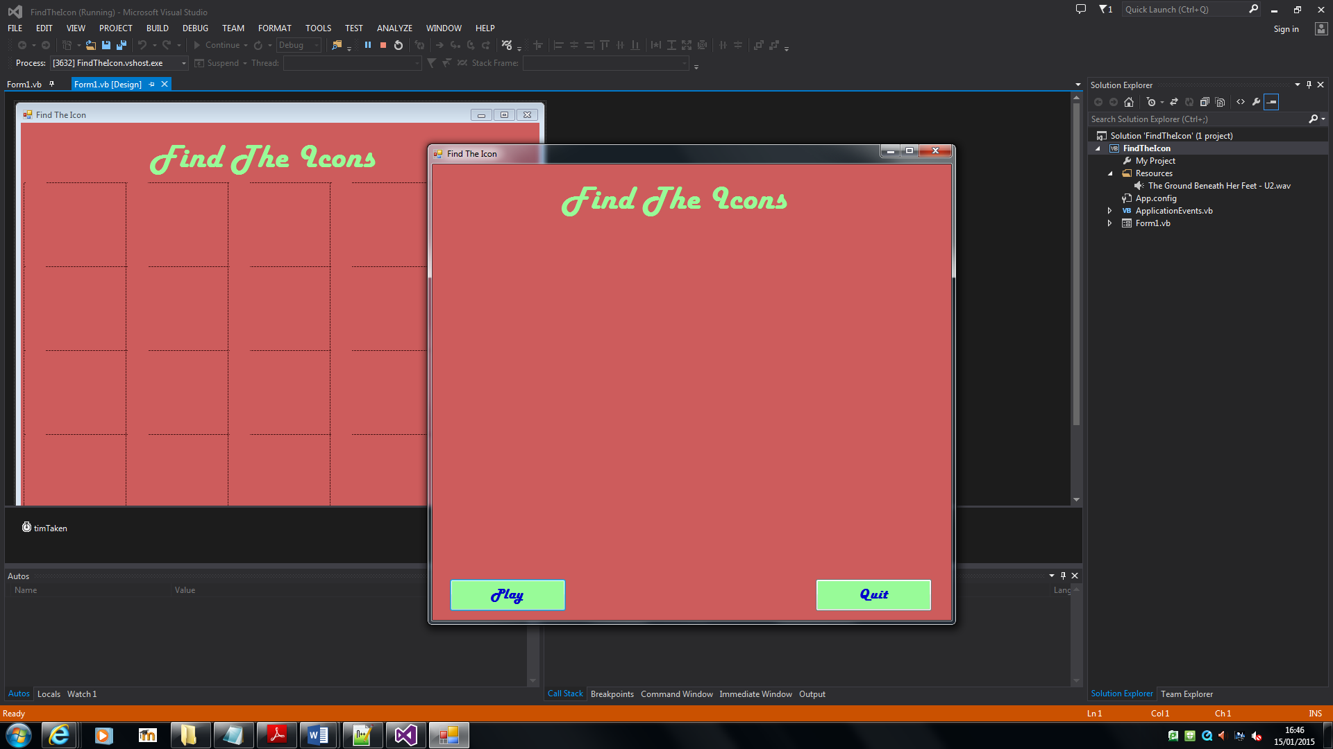Before testing After Testing

Testing the grid

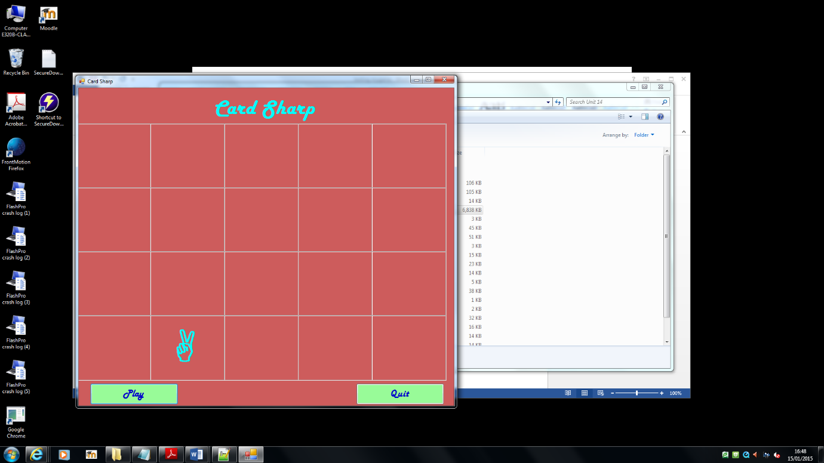

Label testing in code

Private Sub label(sender As Object, e As EventArgs) Handles Label2.Click,Label3.Click, Label4.Click, Label5.Click, Label6.Click, Label7.Click,Label9.Click, Label10.Click, Label11.Click, Label12.Click,Label13.Click, Label14.Click, Label15.Click, Label16.Click, Label7.Click,Label18.Click, Label19.Click, Label20.Click, Label21.Click, Label8.Click, Label17.Click

Private Sub label(sender As Object, e As EventArgs) Handles Label2.Click,Label3.Click, Label4.Click, Label5.Click, Label6.Click,Label10.Click, Label12.Click,Label13.Click, Label14.Click, Label15.Click, Label16.Click, Label7.Click,Label18.Click, Label19.Click, Label20.Click, Label21.Click, Label8.Click, Label17.Click